Self-Learning Face Recognition System
Submitted by: SRI PRIYADHARSHINI T
B.E Computer Science and Engineering
ABSTRACT
Face recognition is essential to modern security and personalization systems. Conventional models, on the other hand, are static and require retraining to accommodate new surroundings or users, which results in inefficiencies and privacy problems.
An adaptive, privacy-preserving framework that continuously learns from fresh data and user input is introduced by the suggested Self-Learning Face Recognition System. To update just crucial model components while safeguarding sensitive data, it integrates incremental learning, federated learning, and differential privacy.
A feedback-validation module makes sure that only validated adjustments update the model, while Elastic Weight Consolidation (EWC) and a replay buffer preserve prior information and avoid catastrophic forgetting. Raw face data never leaves local devices thanks to secure aggregation.
This design produces a privacy-secure, human-like, and continuously improving facial recognition method that may be used in the real world.

OBJECTIVE
To create a self-learning facial recognition system capable of:
Use incremental and federated learning to continuously improve accuracy.
Use memory replay and EWC to retain prior information.
Use decentralized training and differential privacy to safeguard data.
Use feedback filtering based on trust to validate fresh inputs.
Assure security, efficiency, and scalability for authentication applications.

SYSTEM ARCHITECTURE
The system uses five interconnected elements to simulate human adaptability:
The input and preprocessing layer records, aligns, modifies lighting, and confirms liveness.
CNNs or Vision Transformers are used in the feature extraction layer to create discriminative embeddings.
Instead of storing raw photos, the embedding database stores identification labels and secure feature vectors.
Feedback & Validation Engine: Gathers user input and verifies validity prior to learning.
Self-Learning & Privacy Module: Uses differential privacy, EWC, and federated updates for safe and flexible learning.
When combined, these layers allow for ongoing model improvement in practical settings.
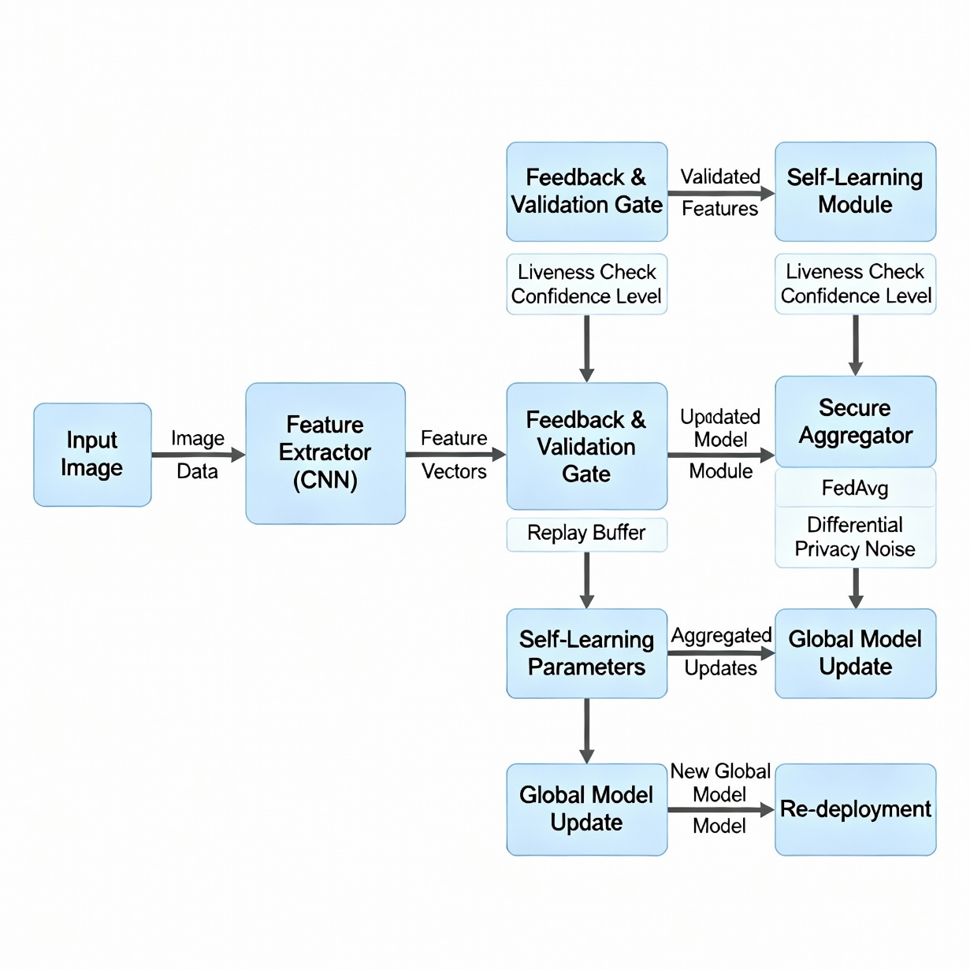
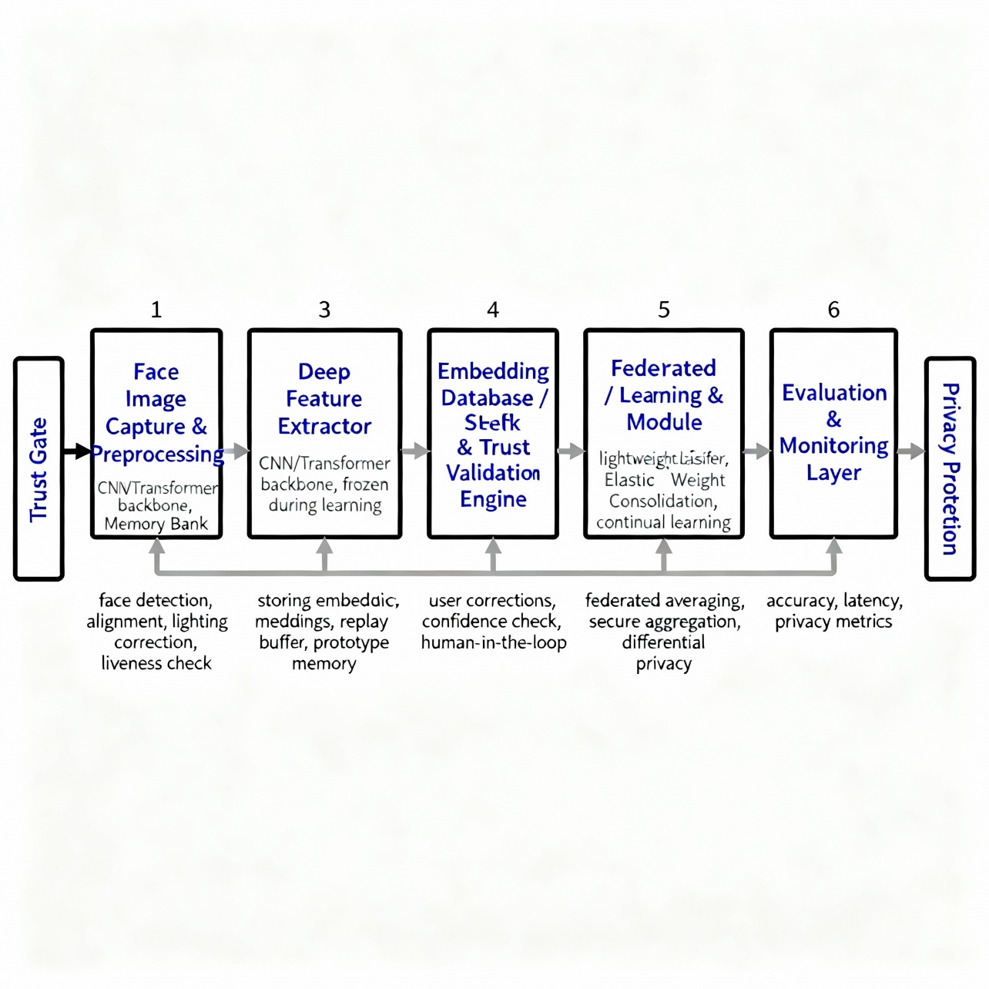

WORKING PROCESS
Face capture and preprocessing include liveness check, illumination adjustment, alignment, detection, and input image acquisition.
Feature extraction: Compact embeddings are produced as digital fingerprints by deep models such as FaceNet/ArcFace.
Recognition: New embeddings are compared to the database using similarity scores, such as cosine similarity.
Feedback Gathering: User validation or correction is triggered by misclassifications.
Trust Gate Validation: Liveness verification and confidence score guarantee the dependability of new samples.
Self-Learning: The model gradually changes while maintaining historical data by using validated feedback, EWC, and a replay buffer.
Federated Aggregation & Privacy: No raw data is exchanged; local updates are encrypted and aggregated worldwide.
Performance Monitoring: To keep a balance between new and old knowledge, accuracy and efficiency are routinely assessed.

KEY TECHNIQUES USED
Adapting to new faces without fully retraining is known as incremental learning.
Federated Learning: On-device learning is guaranteed by decentralized updates.
Differential Privacy: Prevents data reconstruction by introducing controlled noise.
Deep Feature Extraction: CNN-based embeddings offer reliable identification.
Elastic Weight Consolidation (EWC): Prevents catastrophic forgetting by retaining past knowledge.
Replay Buffer: Maintains stability and balanced updates by storing a few previous embeddings.

NEW ASPECTS
Continuous Adaptation without Complete Retraining: EWC and replay buffer provide incremental updates.
Privacy-Preserving Federated Learning: Data stays on the device; only encrypted weight changes are transmitted.
Identity reconstruction from shared updates is prevented via Secure Aggregation with Differential Privacy.
Prototype Alignment & Replay Mechanism: Prevents forgetting and preserves class balance.
Liveness, confidence, and optional human review are all combined in Trust-Gated Feedback Validation to guarantee authenticity.
These developments result in a recognition framework that is safe, human-like, and always changing.

EVALUATION
System performance is evaluated using:

Accuracy Metrics: TPR, FAR, FRR, EER to measure recognition quality.

Plasticity & Retention: Evaluates the harmony between acquiring new identities and holding onto existing ones.

Efficiency: Keeps track of resource usage and update latency.

Federated aggregation reliability and differential privacy (ε, δ) characteristics are used to measure security and privacy.

System Consistency: Regular client comparisons to guarantee stability and equity.

CONCLUSION AND FUTURE SCOPE
A significant step toward ethical, flexible, and privacy-conscious AI is the proposed Self-Learning Face Recognition System. It constantly improves without complete retraining or data centralization by combining incremental, federated, and differential-privacy-based learning.
Reliability is improved by the trust-gated feedback mechanism, while stability is preserved by replay buffers and prototype alignment.
Future improvements will include explainable-AI integration for transparency and user trust, edge-AI acceleration for quicker on-device updates, and multi-modal biometrics (facial + voice).
This framework lays the groundwork for self-improving, human-like biometric systems that guarantee scalability, security, and long-term reliability in practical applications.

